LAB 3: DESIGN SPRINT EXPERIMENT REPORT
Scenario: Parents Struggle to Track Children’s Learning Progress

Aim of the Experiment
The aim of this experiment is to apply the Design Sprint methodology by following the Empathize, Define, Ideate, Prototype, and Test stages to design a user-centred solution for parents who struggle to track their children’s academic learning progress.
The experiment focuses on understanding real parent challenges and validating practical solutions through feedback instead of assumptions.

Problem Context
In today’s digital learning environment, children use school portals, tuition apps, online learning platforms, and messaging groups for academic updates. However, many parents find it difficult to consistently monitor their child’s learning progress.
This results in:
- Lack of clarity about academic performance
- Difficulty tracking homework and assignments
- Poor communication between parents and teachers
- Missed deadlines
- Anxiety about exams and results
- Reduced parental involvement
Parents often rely only on exam results to judge performance, rather than continuous progress tracking.

- Empathize Stage
- 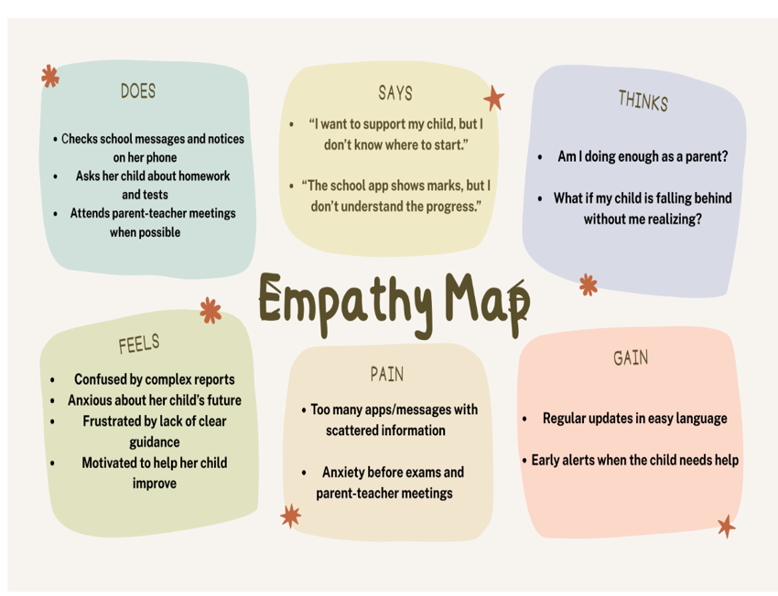
Objective:
To deeply understand the needs, frustrations, and behaviour of parents who struggle to track their children’s learning progress.
Activities Performed:
- Interviewed three parents (working parent, homemaker, and parent of high school student).
- Observed how parents check school apps or WhatsApp groups.
- Discussed challenges faced during exam periods.
Key Observations:
- Parents check updates irregularly due to busy schedules.
- Many parents find school portals confusing.
- Assignments are sometimes communicated through multiple channels.
- Parents depend mostly on exam marks.
- Some parents do not understand subject-wise strengths and weaknesses.
User Insight:
Parents want a simple and centralized system that clearly shows their child’s academic progress, attendance, assignments, and performance trends in an easy-to-understand format.

2. Define Stage
Objective:
To clearly define the core user problem.
Problem Statement:
Parents need a simple and centralized way to track their child’s academic progress because scattered information and complex school systems make monitoring difficult.
How Might We (HMW) Question:
How might we help parents easily monitor and understand their child’s learning progress without requiring technical knowledge or constant checking?

3. Ideate Stage
Objective:
To generate multiple possible solutions.
Brainstormed Ideas:
- Centralized Parent Dashboard App
- Weekly Progress Report Notification
- Performance Trend Graph
- Homework Reminder System
- Teacher Feedback Section
- AI-based Academic Strength & Weakness Analyzer
- Attendance Alert System
- Parent-Teacher Chat Feature
- One-Click Summary Report
Idea Selection:
Selected Idea: Smart Parent Progress Tracking Application with Real-Time Updates and Weekly Summary Reports.
Justification:
- High value for parents
- Easy to use
- Reduces confusion
- Encourages parental involvement
- Technically feasible

4. Prototype Stage
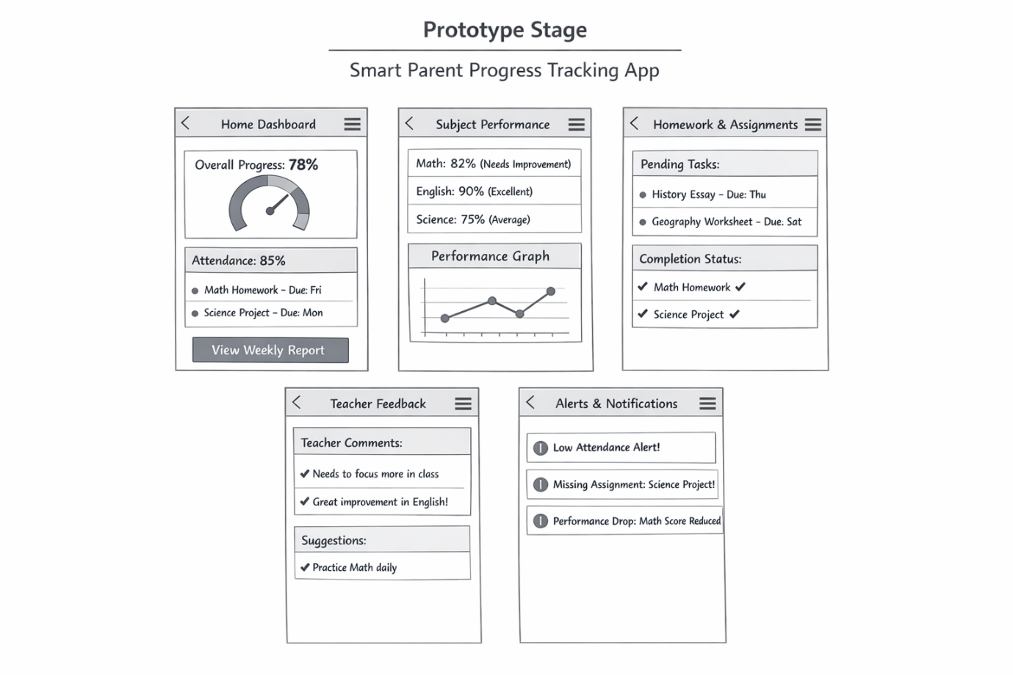

Objective:
To create a low-fidelity prototype representing the solution.
Prototype Description:
The prototype includes simple wireframe screens:
1. Home Dashboard Screen
- Child’s overall performance percentage
- Attendance summary
- Upcoming assignments
- “View Weekly Report” button
2. Subject Performance Screen
- Subject-wise marks
- Strength and weakness indicators
- Performance graph
3. Homework & Assignment Screen
- List of pending assignments
- Due date reminders
- Completion status
4. Teacher Feedback Screen
- Comments from teachers
- Suggestions for improvement
5. Alert & Notification Screen
- Low attendance alert
- Missing assignment alert
- Drop in performance warning
Design Rationale:
- Simple layout for easy navigation
- Clear charts and visual graphs
- Large readable fonts
- Minimal technical terms
- Color indicators (green = good, red = needs improvement)
Prototype Type:
Low-fidelity paper wireframes / basic digital mock-ups.

5. Test Stage
Objective:
To test the prototype and collect real user feedback.
Testing Method:
The prototype was shown to three parents:
- Working parent
- Homemaker
- Parent of high school student
They were asked to:
- Check weekly performance
- Identify weak subjects
- View pending assignments
- Review teacher feedback
Their interactions were observed and feedback recorded.

User Feedback Summary
User 1 (Working Parent):
Found the dashboard very helpful and liked the weekly summary feature. Suggested adding push notifications for important updates.
User 2 (Homemaker):
Appreciated the subject-wise performance graph. Requested simple explanations of academic terms.
User 3 (High School Parent):
Liked the homework tracking feature but suggested adding exam schedule reminders.

Observations
- All users easily understood the dashboard layout.
- Parents preferred visual graphs over detailed tables.
- Notifications were considered very important.
- Simplicity was valued more than advanced features.
- All users said they would use the app regularly.

Iteration and Improvements
Based on feedback:
- Add push notification system
- Include exam schedule reminders
- Add simple explanations for academic terms
- Provide monthly performance comparison
- Add dark mode for better usability

Reflection
Initially, it was assumed that parents lack interest in tracking progress. However, testing revealed that the real issue is lack of clarity and centralized information.
Parents are willing to be involved but need a simple, organized, and time-efficient tool. The Design Sprint process helped uncover hidden pain points and refine the solution through user feedback.

Conclusion
The Design Sprint methodology successfully guided the development of a user-centred solution for parents struggling to track their children’s learning progress.
By focusing on empathy, defining the correct problem, generating ideas, prototyping, and testing with real users, a practical and easy-to-use solution was designed.
This experiment highlights the importance of clear communication, simplicity, and continuous feedback in educational technology solutions.

NAME :SONAVI K
REGISTER NUMBER: 24BEIS122

